Spur Gear Generator

The Spur gear Generator is accessed from the Utilities Menu

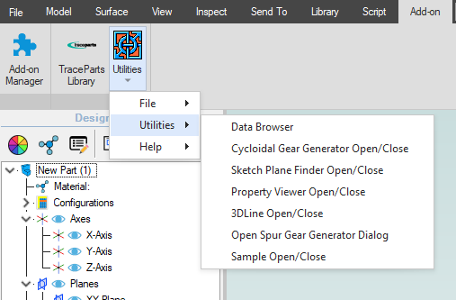

Once opened you will see the Gear Generator dialog

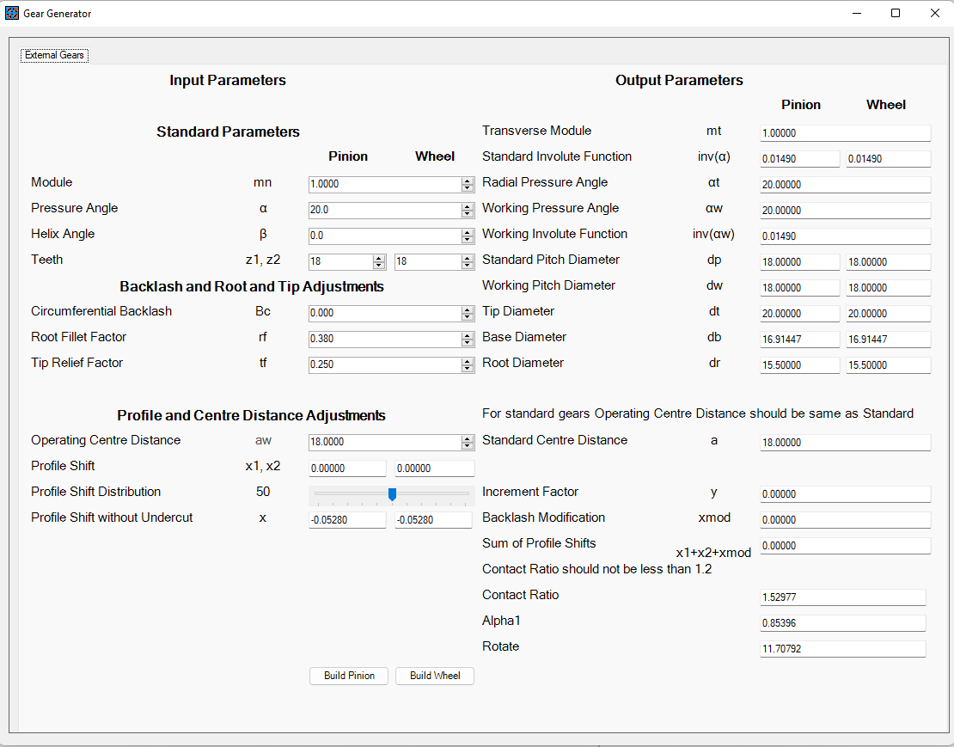

Parameters, Abbreviations and Definition

|  |  |  |
| --- | --- | --- |
| Parameter | Abbreviation | Definition |
| Module | mn | Normal (Metric) Module of the gear. Imperial Pitch diameter is 25.4/mn |
| Pressure Angle | α | Gear pressure angle in degrees. Gears are often specified for 20° pressure angle but 14.5° is also used. |
| Helix Angle | β | Helix angle for helical gears. Common values are 15°, 20°, 30° and 45°. 45° is the usual upper limit. |
| Teeth | z1, z2 | Count of teeth on the gears. |
| Backlash | Bc | Backlash factor |
| Root Fillet Factor | rf | Diameter of the root fillet as a fraction of the module size. |
| Tip Relief Factor | tf | Diameter of the tip (addendum) relief as a fraction of the module size. |
| Operating Centre Distance | aw | Gear operating centre distance in mm. For ‘Standard’ gears this should be set to the same value as the Standard centre distance. |
| Profile Shift | x1, x2 | When designing gear pairs, the operating centre distance is often adjusted to better meet the design requirements.  The profile shift is the factor by which the gear tooth is either extended (positive shift) or flattened (negative shift) in order to ensure correct meshing of the gears. |
| Profile Shift Distribution |  | The relative distribution of the profile shift between the gear pair. Note that the profile shift should not fall below the profile shift without undercut figure. |
| Profile Shift without undercut | x | The maximum allowable profile shift before undercutting will be required. (Note that this application does not support the generation of gears with undercut) |
| Transverse Module | mt | The transverse module size in mm. This figure will be the same as |
| Standard Involute Function | Inv(α) |  |
| Radial Pressure Angle | αt |  |
| Working Pressure Angle | αw |  |
| Working Involute Function | Inv(αw) |  |
| Standard Pitch Diameter | dp |  |
| Working Pitch Diameter | dw |  |
| Tip Diameter | dt |  |
| Base Diameter | db |  |
| Root Diameter | dr |  |
| Standard Centre Distance | a |  |
| Increment Factor | y |  |
| Backlash Modification | xmod |  |
| Sum Profile Shifts | X1+x2+xmod |  |
| Contact Ratio |  |  |
| Alpha 1 |  |  |
| Rotate |  |  |
|  |  |  |
|  |  |  |